Week 2 – Security Planning and Testing Methodology
1. Performance Testing Plan and Remote Monitoring Methodology
Objective
The performance testing plan has one goal, which is to see what different workloads will do to the behaviors of the Linux operating system when it is being administered remotely. The performance metrics will be obtained through the exclusive use of command-line tools run through SSH from the workstation system, and thus the requirement of coursework for remote administration will be met.
The performance testing will take place in several phases—observing the baseline behaviors, the load that the application induces and, finally, the effects of optimization.
Remote Monitoring Methodology
The whole monitoring process will take place on the Ubuntu Desktop workstation connecting to the Ubuntu Server using SSH. The data collection process will be based on native Linux command-line utilities to ensure there is no unnecessary overhead and that a lightweight monitoring approach is maintained.
The methodology that follows will be used:
- Build SSH connection from workstation to server
- Run monitoring commands from a distance
- Get output in real time
- Send results to files if needed for later analysis
- Take measurements again for consistency and comparison
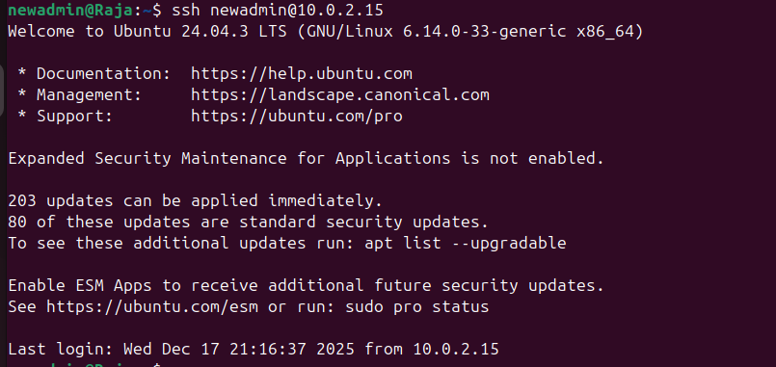
Performance Metrics to be Measured
Metric | Description | Tools
CPU Usage | Processor utilization under load | top, htop, mpstat
Memory Usage | RAM and swap usage | free -h, vmstat
Disk I/O | Read/write performance | iostat, df -h
Network Performance | Throughput and latency | ping, iperf3
System Load | Overall system stress | uptime, loadavg
Service Response Time | Application responsiveness | Application-specific tools
Testing Approach
The subsequent application testing will adhere to the structured approach of each phase as follows:
- Baseline Measurement: Evaluate the system performance under conditions of slight background activity only.
- Load Testing: Deploy the application workload and check the system's response.
- Bottleneck Identification: Locate limitations connected to CPU, RAM, disk or network.
- Optimization Testing: Enhance settings and then conduct performance re-test.
- Comparison and Analysis: Use numerical data and graphs to compare results.
Figure 1: CPU Usages
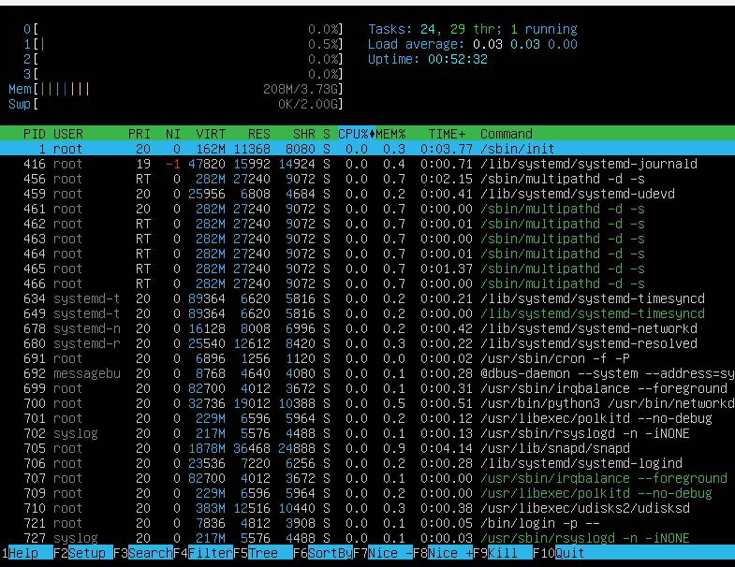
Figure 2: Memory Monitoring Tool

Figure 3: Disk Monitoring Tool
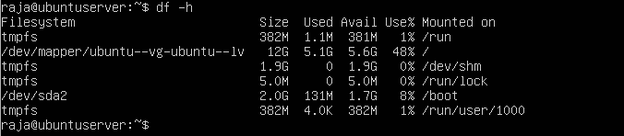
Figure 4: Network Monitoring Tool
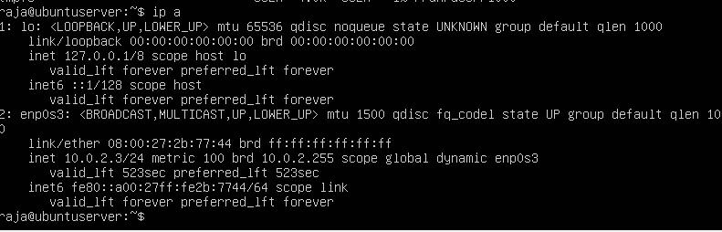
By employing this methodology, it is guaranteed that different types of workload testing would be done consistently and repeatedly.
2. Security Configuration Checklist
A security baseline was crafted to clarify the essential controls that would be applied during the subsequent stages. This checklist is in line with the industry’s best practices and the academic coursework requirements.
SSH Hardening
- No password-based authentication
- Key-based authentication only
- SSH access is limited to one administrator
- Default SSH configuration has been changed to make it less vulnerable
- Strong cryptographic algorithms are mandatory
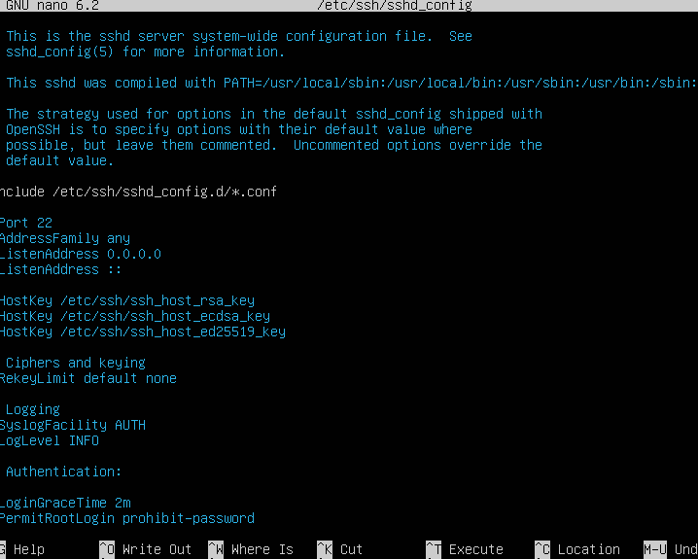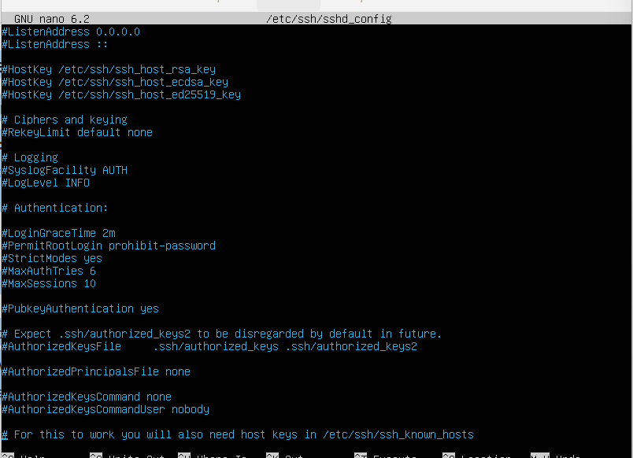
Firewall Configuration
- Firewall must be active on the server (UFW)
- Only SSH traffic will be allowed
- All other incoming connections will be denied by default
- Connection attempts that are blocked will be logged
- Firewall rules must be verified after configuration

Mandatory Access Control
- Enabling AppArmor (the default on Ubuntu)
- Application profiles will be enforced
- Access control violations will be monitored and logged
- AppArmor status tools will be used to validate profiles
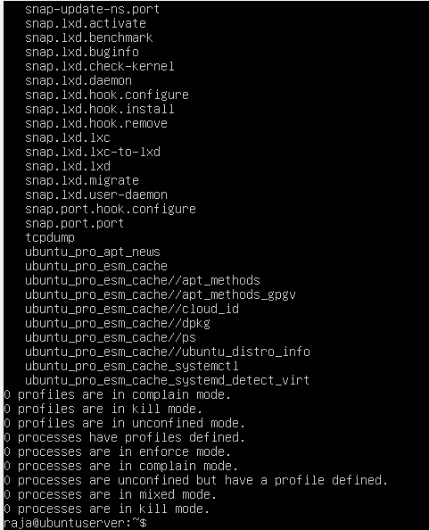
Automatic Security Updates
- The unattended-upgrades will be enabled
- Only security updates will be applied automatically
- Update logs will be checked regularly
- Exposure window for known vulnerabilities will be reduced
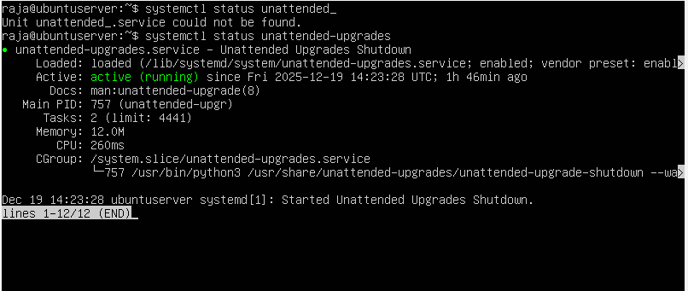
User Privilege Management
- An administrative user of non-root type will be created
- Direct root access via SSH will be disabled
- The principle of least privilege will be applied
- Sudo command will be used for elevated operations
- User permissions will be audited regularly
Network Security
- Exposed services will be limited
- Only necessary ports will be open
- Listening services will be checked using network tools
- Isolation within the NAT Network environment will be maintained
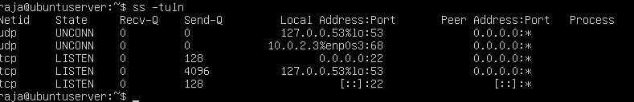
3. Threat Model
A threat model was compiled to pinpoint the risks the server system might face and to propose suitable measures for their reduction.
Threat 1: Unauthorized SSH Access
Description:
An attacker may try to get access to the server using either brute force or credential-based methods through SSH.
Impact:
The system's integrity will be compromised, and unauthorized access will be granted which might lead to loss of data.
Mitigation Strategies
- Authentication based on SSH keys
- Turn off authentication via passwords
- Restrictions of a firewall
- Fail2ban for detection of intrusion
Threat 2: Misconfigured Services or Open Ports
Description:
Running unnecessary services or physically open ports can put the system in danger of attacks.
Impact:
The system's increased vulnerability to an attack and exploitation.
Mitigation Strategies:
- Rules for firewall default-deny
- Audits of services performed regularly
- Scanning the network with nmap
- Installation of minimal services
Threat 3: Privilege Escalation
Description:
The user account that is compromised may then try to climb up the privilege ladder to root.
Impact:
Total loss of control and compromised system.
Mitigation Strategies:
- User with non-root administrative power
- Limited access to the sudo command
- Use of Mandatory Access Control (AppArmor)
- Audits of permissions done regularly
Conclusion
In Week 2, the development of a well-established security baseline and a performance testing methodology occurred, which would serve as a guide for the implementation phases of the coursework. A very detailed checklist was produced to make it possible to apply all the required security controls in a systematic way. The threat model pointed out the most significant risks for the server system and proposed the corresponding mitigation strategies that complied with best practices. Besides, a performance testing approach that is both repeatable and reliable was planned, thus facilitating OS behavior analysis under different workloads.

